Insurance Agent Portal

IAP - 001

Program Specifications (Client Server Environment)

**Record of Release**

|  |  |  |  |  |  |
| --- | --- | --- | --- | --- | --- |
| **Version No.** | **Modified By** | **Reviewed By** | **Authorized By** | **Release Date** | **Modifications Done** |
| 1.0 | Varun K., Kartik P.,Shreyash A. | Simran K. | Jitesh M. | 30-08-20 |  |
|  |  |  |  |  |  |
|  |  |  |  |  |  |
|  |  |  |  |  |  |
|  |  |  |  |  |  |

**Table of Contents**

***1.0 Introduction 3***

*1.1 Objective 3*

*1.2 Function Specification reference details 3*

*1.3 References 3*

***2.0 Database Design 3***

*2.1 Module Related ERD 3*

*2.2 Tables 3*

*2.3 Indexes 3*

*2.4 Views 4*

*2.5 Others 4*

***3.0 Screen Design 4***

***4.0 Reports Design 5***

***5.0 Backend Design 8***

*5.1 Index of Reference 8*

# Introduction

## Objective

The objective of this document is to provide detailed technical specifications about the Home Page module of the Insurance Agent Portal*.* This document includes information on the Database Design, Backend Programming, Screens, and Reports layouts.

## Function Specification reference details

|  |  |  |
| --- | --- | --- |
| **Business Function Name** | **Program type** | **Name of the Program** |
| Home Page  Open page of Insurance portal. | Visiting Site | Home Page |

## References

|  |  |
| --- | --- |
| **Document Name** | **Purpose** |
| DLD_SSAD | Detailed Design regarding the module is given. |

# Database Design

## Module Related ERD

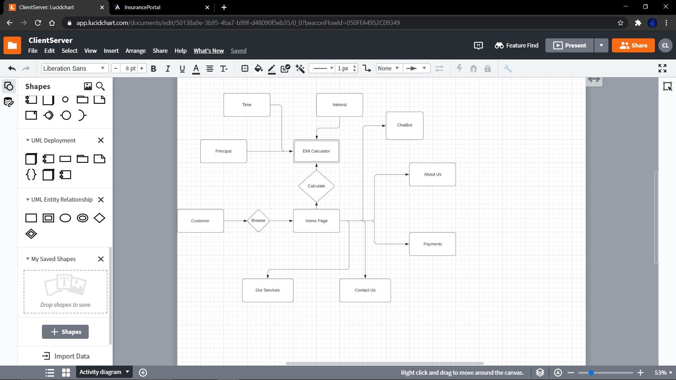

## Tables

* + 1. **Owned by Module**

|  |  |  |
| --- | --- | --- |
| **Sr.No.** | **Table Name** | **Table Description** |
| 1. | Queries | All the feedback and queries received from the customer is stored. |

* + 1. **Referred by Module**

|  |  |  |
| --- | --- | --- |
| **Sr.No.** | **Table Name** | **Table Description** |
| 1. | Payments | Payments details received by the agent through the customer. |
| 2. | Appointment | Registering appointments of customer with the agent. |
| 3. | Images | Images to be displayed through Slideshow on Home Page. |

## Indexes

E00101

# Screen Design

## Home Page

Insurance Agent Portal Home Page

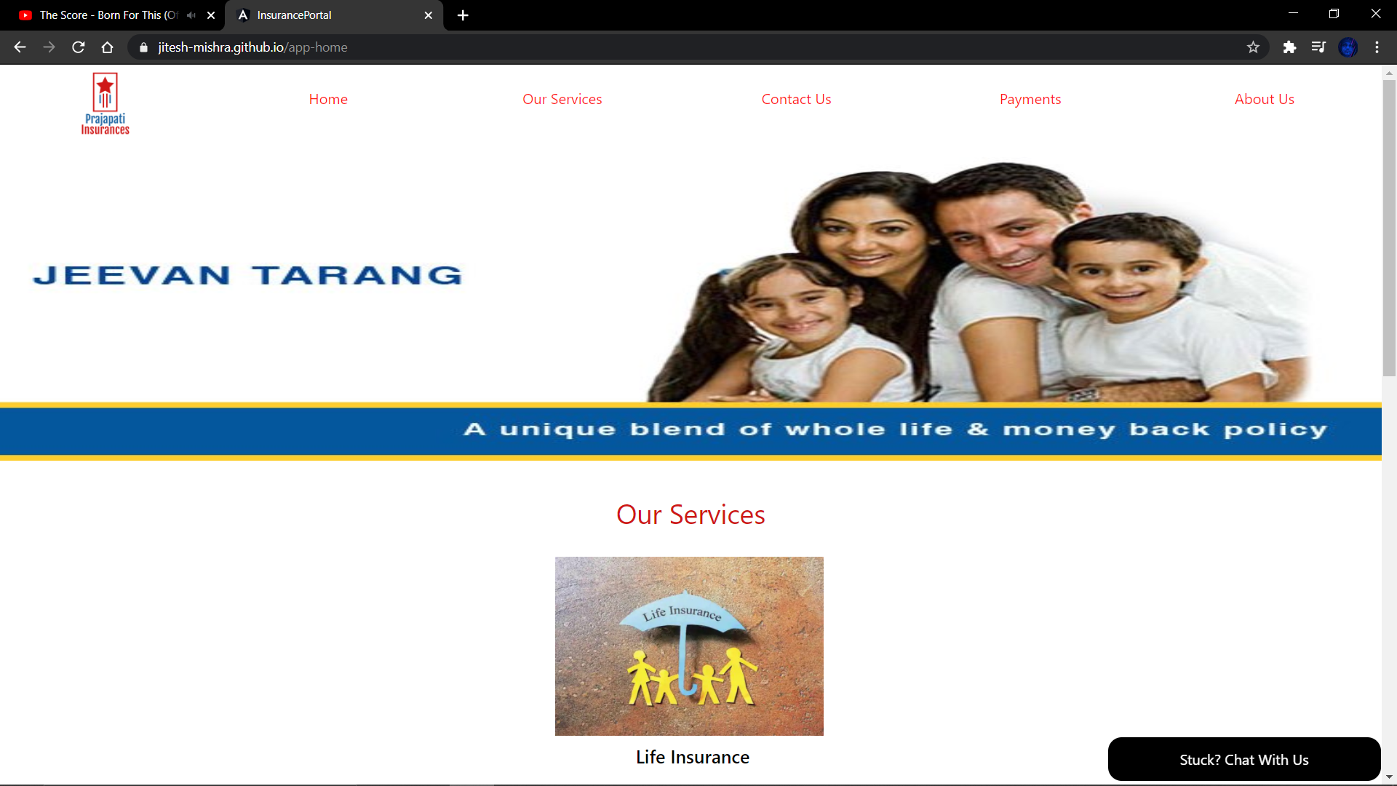

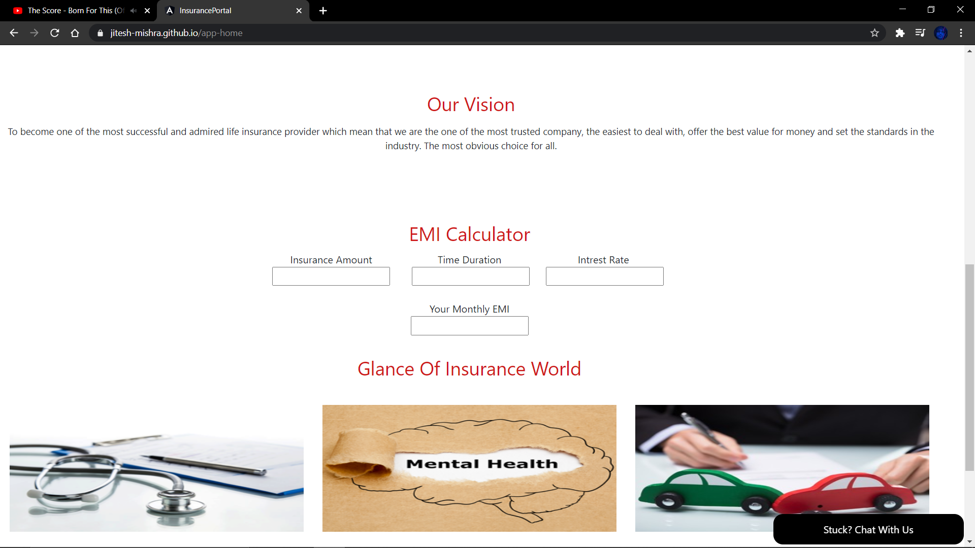

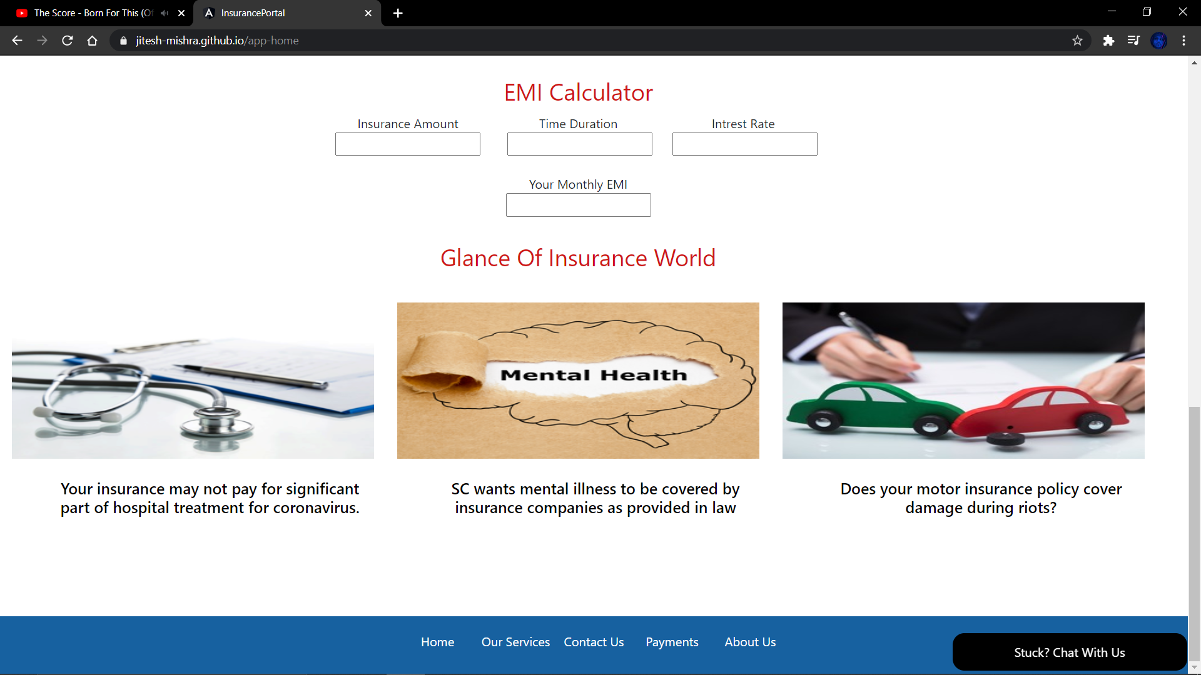

* + 1. **Brief description / Functionality**

The Home Page gives an overall view of the Agent and his services along with calculating your EMI for free.

* + 1. **Parameters received**

|  |  |  |
| --- | --- | --- |
| **Parameter** | **Data Type** | **Description (usage)** |
| **Queries** | **Character, String** | **Used to store feedback or any queries received from the customer.** |
| **Values for EMI Calculator** | **Integers** | **Used in Calculation of EMI for the given principal amount, rate of interest and the time period.** |

* + 1. **Screen / reports / programs / interfaces called and parameters passed**

|  |  |  |  |  |
| --- | --- | --- | --- | --- |
| **Sr. No.** | **Screen / Report / Program / Interface Name** | **Description (Usage)** | **Parameter** | **Data Type** |
| **1.** | **EMI** | **EMI calculated from the EMI Calculated.** | **Principal Amount, Rate of Interest, Time Period** | **Integer, Double** |

* + 1. **Screen Navigation Logic**

Screen navigation takes place through the Header, Footer, or the Chatbot. The Home Screen is updated only when the user/ customer enters values in the EMI calculator to generate an EMI amount. If selected one of the options from the Header, Footer, or Chatbot the user is navigated or taken to the respective screen.

* + 1. **Layout**

|  |  |  |
| --- | --- | --- |
| **Layout Name** | **Type\*** | **Description** |
| Amar Bima | Main Screen | The Layout of the Portal is that of Amar Bima with different contents. |

* + 1. **Screen Layout**

The layout is in the Screen Layout folder along with the pictures of layouts in it.

# Backend Design

## Index of Reference

Reference index for Home Page is: E00101

It is maintained in MYSQL technique using SQL server

## Library: homepage

* + 1. **Function: homePage**

#### Brief Description / Functionality

* It stores data of different classes in the Home Page module.

#### Parameters

|  |  |  |  |
| --- | --- | --- | --- |
| **Parameter Name** | **Description** | **Data Type** | **Input/output** |
| Horizontal Slider | Stores data for slider situated at the top of the page. | Image | NULL |
| Our Services | Our Services Section | Text, Images | NULL |
| Our Vision | Our Vision Section | Text | NULL |
| NEWS Section | Data of News Section | Text, Images | NULL |

#### Screens/Reports/Programs called

Null

#### Business rules for data manipulation

Data manipulation shall be done in maintenance as per customer requirements.

#### Tables Used with access mode

The access mode is not required in this module for any tables.